MMA YEARLY OUTLOOK
THE JAPANESE NIKKEI STOCK MARKET IN 2026
By RAYMOND MERRIMAN, C.T.A.

REVIEW

The Nikkei was bullish throughout most of 2025. Following an all-time high of July 11, 2024, at 42,426, the Nikkei fell to double bottom lows of August 5, 2024, at 31,156 and 30,792 on April 7, 2025. The letter low coincided with U.S. President Donald Trump’s “Liberation Day” announcement of steep tariffs on any U.S. companies importing goods outside of the country. World stock indices, including the Nikkei, went into a min-panic and sold off sharply in early 2025.

However, President Trump then began backing off his tariff proclamations and many world indices rebounded to new all-time highs after April 7, 2025. As of this writing in late November 2025, the Japanese Nikkei has posted a new all-time high of 52,636 on November 4, 2025. This represents a gain of over 70% in just seven months. Not only was the high above that of the prior year, but the yearly low was also below that of the previous year. This is known as a “bullish key reversal up” technical signal on a yearly level.

Thus, we begin the year 2025 with some slight adjustments in our long-term cycles analysis as given last year

Cycle | Start/Progress | Next Due
19-year | October 2008, 18 years | 2025-2030
9.5-year | March 2020, 6 years | 2027-2031
6.33-year | March 2022, 4 years | 2027-2030
4.17-year | August 2024 , 17 months, or April 2025 months | April 2028-January 2029 or  December 2028-September 2029
23-month | August 2024, 17 months, or  April 2025, 9 months | May-September 2026 or  January-May 2027

THE 19-YEAR CYCLE

A review of Japanese Nikkei stock index since 1950 reveals the possibility of a 19-year cycle with a range of 17-21 years. This is slightly longer than the 17-year cycle we had been using, but it fits well if longer-term cycles are considered for June 1950, May 1970, November 1987, and October 2008. If this is correct, then the next 19-year cycle would be due 2025-2029.

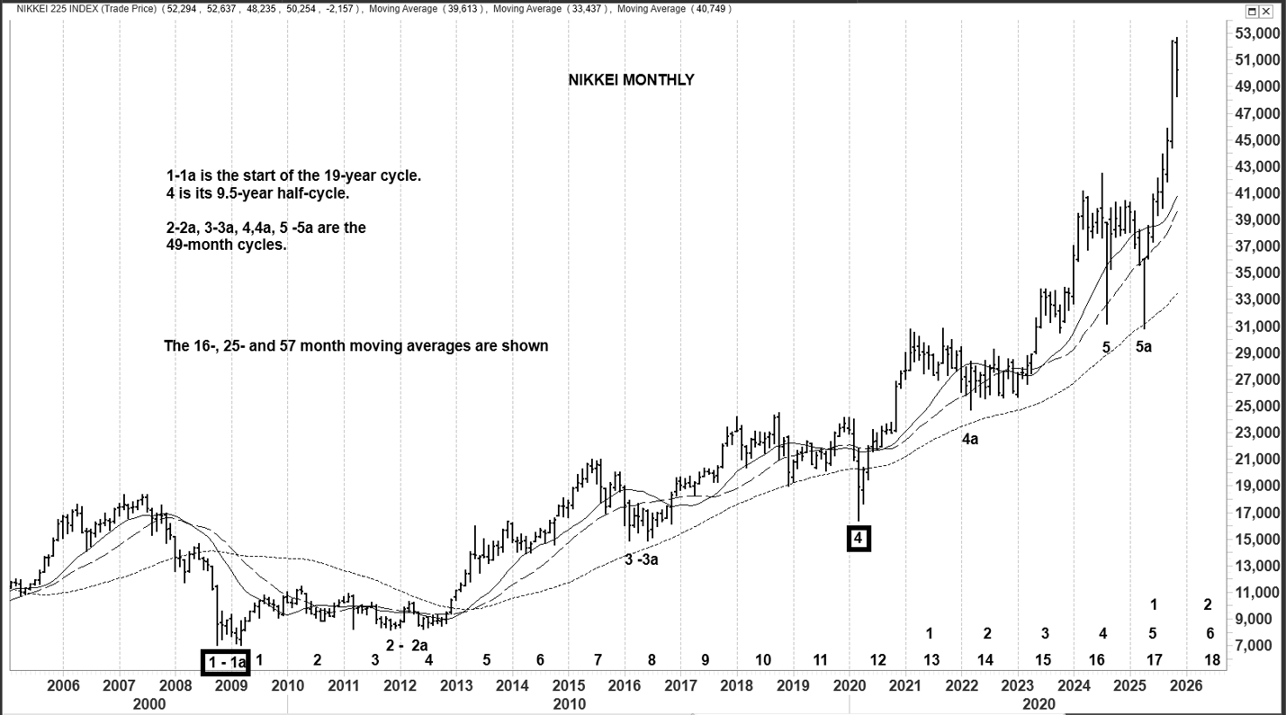

THE 9.55-YEAR CYCLE

As written before, all market cycles break down into 2- or 3-phase patterns, which are sub-cycles of approximately equal length. Sometimes both patterns appear in the same cycle (“combination pattern”). In previous years, we have assumed that the 17-year cycle breaks down into two half-cycles of 8.33 years. But with the revised cycles labeling, we can see it breaks down into either two half cycles of 9.5 years with a range of 7.5-11 years (it could also be considered 9.25-years based on this), or a three-phase pattern of sub-cycles with a periodicity of 6.33 years and a range of 5-8 years. Measured from the double bottom lows of the 19-year cycle in October 2008 and March 2009, we can see a 7.5-11-year half cycle bottoming with the Pandemic low of March 2020, approximately 11 years later. The next half-cycle is therefore due in 2027-2031 and will overlap with the greater 19-year cycle due in 2025-2030.

THE 6.33-YEAR CYCLE

It is also possible to identify a 3-phase pattern of 6.33-year sub-cycles unfolding with a range of 5-8 years since October 2008 (and even before). The double bottom lows of February and June 2016, during the Brexit turmoil in the United Kingdom, would qualify. The next would have been due 2021-2024. There was a notable low in March 2022, although it was not as significant as either the low in March 2020 or April 2025. It could still qualify as a 5-8 year cycle based on its pattern. If it is applicable, it is next due in 2027-2030. However, as it was not as pronounced as the March 2020 or April 2025 lows, we will assign greater weight to the 19-year cycle breaking down into two dominant 9.5-year half cycles. Thus, we will focus upon the phases of the 9.5-year cycle for further guidance in our market timing calculations.

THE 49-MONTH CYCLE

The 9.5-year half cycle doesn’t quite break down into two 4.75-year cycles. More often, it breaks down into 49 month cycles with a range of 44-53 months. These can be seen on the enclosed monthly chart with several double bottom lows, such as October 2008 and March 2009, November 2011 and June 2012, February and June 2016, March 2020 (no double bottom in the pandemic crisis), and then the last double bottom of August 2024 and April 2025. The last one is particularly interesting because the first leg of the double bottom, in August 2024, fell on time in the 53rd month. But the Trump Tariff mini-panic of April 7, 2025, was slightly lower, at an expanded 61 months. Thus, we can add 44-53 months to both of these dates to project the next time band for this cycle low, which comes to April 2028-January 2029, or December 2028-September 2029. It is interesting because both counts overlap December 2028-January 2029.

As one will notice on the monthly chart, all instances of the 49-month cycle witnessed the Nikkei touching or falling below the 57-month moving average (half the length of 9.5 years), if we use the low of April 7, 2025, instead of the low of August 2024. Normally this would support the idea that the next low will be January-October 2027. However, we must keep in mind that if a cycle expands, as it would have in the April 2025 instance, the next cycle could very well contract (less than 44 months), which means it could bottom even before April 2028. This illustrates one of the basic rules of the MMA method of analysis whereby it becomes very challenging to identify the bottom of a cycle when it corresponds to longer-term cycles. And given that this is also around the time when the 19- and 9.5-year longer-term cycles are due, investors need to be prepared for some very bizarre market behavior to unfold when that long-term cycle unfolds. The strategy will be to start a long-term buying or investment program once the Nikkei (and other world indices) falls at least 37-63% from its all-time high at any time between 2026 and 2030. Don’t wait for the shorter-term cycles to fall on time to begin. Focus on the greater 19-year cycle time band, for that longer-term cycle will likely be on time. But know that it can (and probably will) distort the smaller phases within it.

THE 23-MONTH INTERMEDIATE-TERM CYCLE

The 49-month cycle has also been sub-dividing into two 23-month phases, although they are not as clear and consistent as the 49-month and longer ones. This may be due to the fact that sometimes the 9.5-year cycle sub-divides into three phases of 3-year cycles instead of two 49-month phases.

Measured from the start of the 9.5-year cycle in March 2020, a 23-month half-cycle occurred on March 9, 2022, shortly after the Russian invasion of Ukraine. That was a decline of nearly 20%.

If we go back and start with the low of October 2008, we will see that this cycle occurred eight consecutive times through March 2022 with a range of 21-25 months. However, it then failed to happen in the normal range, which would have been December 2023-March 2024. Instead, it double-bottomed in August 2024 (29 months) and April 2025 (37 months). In either case, it was an expanded cycle, suggesting that the cycles following the Pandemic low of March 2020 (9.5-year) may be switching from a 2-phase pattern (49-month cycles) to a three-phase pattern closer to 3-years each (say with a range of 30-42 months). It’s too early to confirm such a cycle, so we will stay with those that have been identified in the table earlier in this chapter, and assume the April 7, 2025, low was a distortion. And we will keep in mind that the more distortions we see, the closer the Nikkei is to the explosion of the greater 9.5- and 19-year cycles.

For purposes of this labeling, the next 23-month cycle as measured from the low of August 5, 2024, would be due May-September 2026, or if measured from the low of April 7, 2025, it would next be due January-May 2027.

THE 8.5-MONTH CYCLE

The 23-month cycle breaks down into three 8.5-month cycle phases, with a range of 7-10 months. The recent lows of August 5, 2024, and April 7, 2025 (8 months apart) were examples of this cycle. Since the April 7 low was a longer-term cycle, the Nikkei either completed its first 8.5-month cycle low on November 9, 2025 (7th month), or it is still forming as of this writing and due by the end of February 2026. Then the second of three of these phases will begin and will end with the 23-month cycle trough due January-May 2027. If the correct count began with the low of August 5, 2024, and its second phase ended November 19, 2025, then this is the third 8.5-month phase and it would be due again June-September 2026 with the 23-month cycle trough. Once again, these shorter-term cycles are showing unusual behavior, suggesting that a longer-term cycle is readying to assert its dominance (bearish).

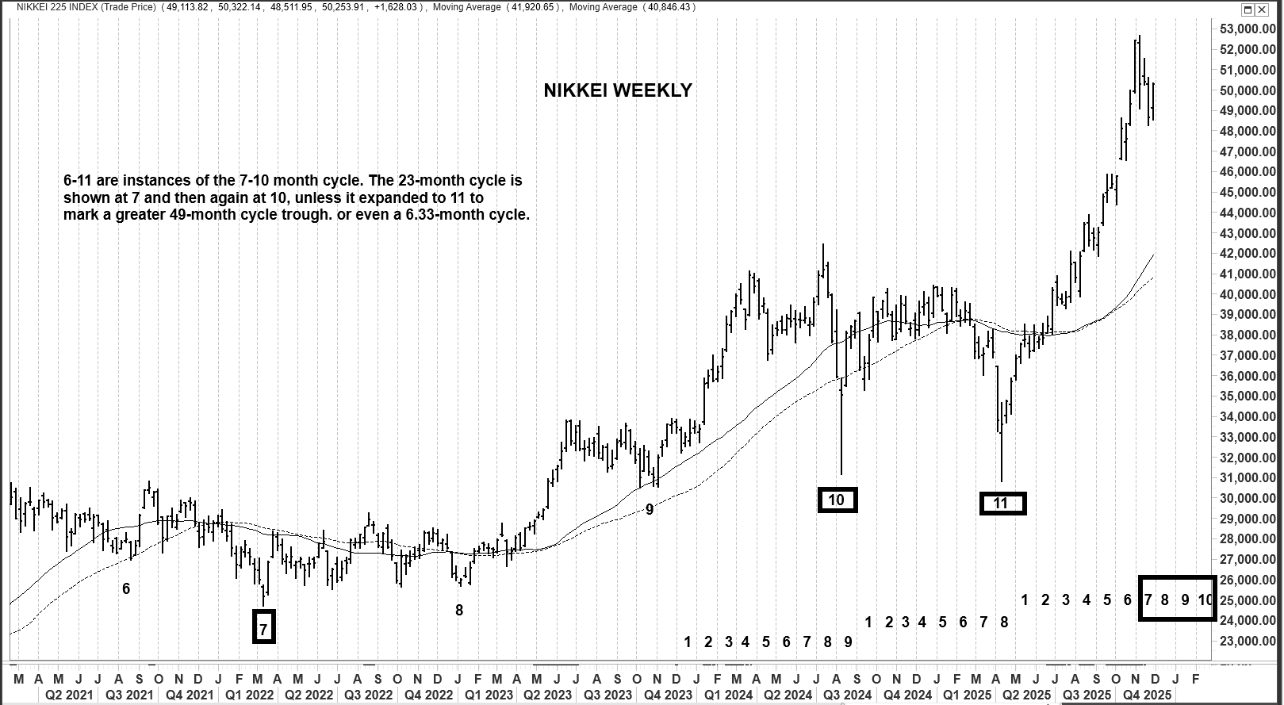

GEOCOSMICS: SATURN-NEPTUNE AND “THE NIKKEI BUBBLE”

One of the most valuable methods for narrowing the time band for cycle periods is the field of geocosmic studies or astrology. The current Nikkei behavior is no exception. In this study, the planets Uranus and Neptune relate to explosive price moves and bubbles. Uranus can be parabolic price activity, and Neptune can be the presence of a bubble where it seems the rally will never end.

Of particular interest is the 36-year planetary pair cycle of Saturn and Neptune. These two planets are currently in their conjunction aspect, from mid-2025 through February 2026, but they can have an orb of up to 10 months before the first period and after the last to complete a long-term Nikkei market cycle.

If we look at the only three cases of this 36-year cycle since 1950, we will see all-time highs – and even bubbles – have formed in each case. The first occurrence was the three-passage series from November 1952 through July 1953. In the chart below, you can see this all-time high in the Nikkei occurred then. It was at least the crest of a 6.33- or 9.5-year cycle.

The second occurrence was another three-passage series form March 1989 through November 1989. This was truly a bubble as the Nikkei soared from approximately 6850 in October 1982 to 38,957 in December 1989. Japan was an economic superpower then, buying up the world.

We are now in the next Saturn-Neptune conjunction period, and once again, the Nikkel stock index is on a tear to new all-time highs, having soared from a low of 6995 in October 2008 to over 50,000 as this is being written in November 2025.
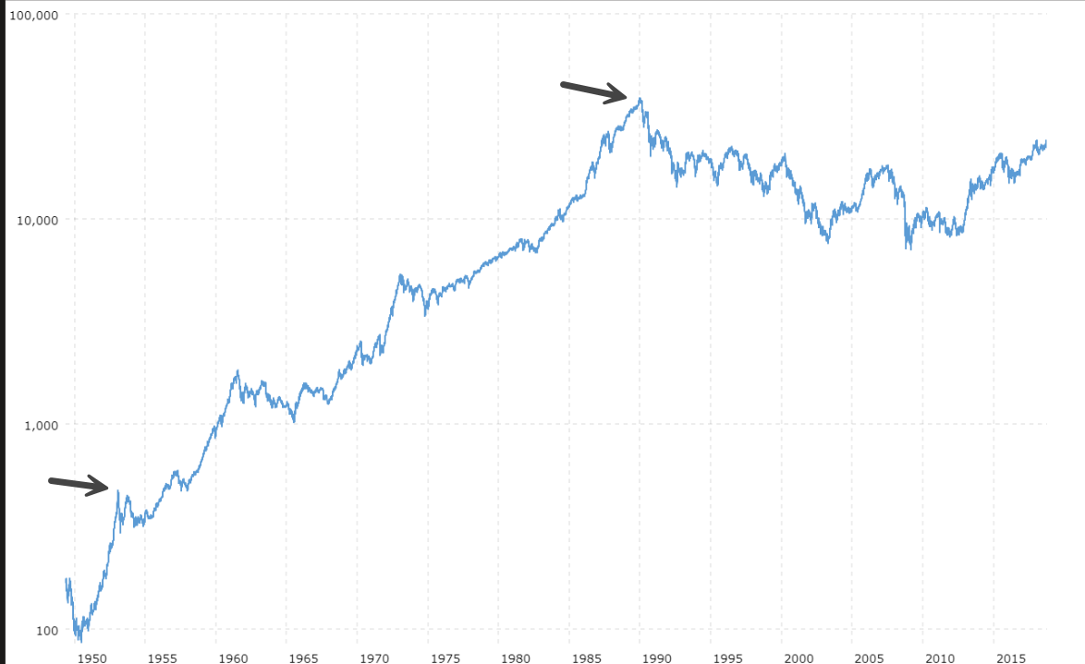

The last two Saturn-Neptune cycles saw the Nikkei complete its bubble very close – within one month – of those conjunctions. If that is to happen again in the current instance, it would mean the bubble peaks by March 2026.

If we examine the 9-year quarter cycle phases of this planetary cycle (the squares and oppositions), we will see long-term cycles peaked and bottom nearby then too, but with a little more orb in time. For instance, the first quarter square (waxing or opening square) after the 1952-53 conjunction happened with a single passage in February 1963. The Nikkei was in a bull market then too, peaking with another new all-time high nearby to the square. The last waning square between these two planets took place in a 3-passage series between November 2015 and September 2016. The crest of the 6.33-year cycle occurred in June 2015,just five months before the aspect started. But the 6.33-year cycle low occurred right in the central time band, in February and June 2016. In all but one of these nine cases, a long-term cycle crest occurred within 9 months of these aspects, and most within the central time band when the aspect was a 3-passage series.

It is happening again. The present conjunction is coinciding with new all-time highs in the Nikkei, and in fact it appears a bubble is unfolding while we are in the central time band of August 2025 through February 2026. Allowing for a 9-month orb, this would imply that the all-time high and long-term cycle crest could very well culminate before the end of 2026, and very possibly close to the last passage in February 2026.

There are at least three periods that stand out as potentially very important turning points for the Nikkei in 2026. The first is February 2026, +/- one month, when Saturn makes its only exact conjunction to Neptune on February 20. In the previous case of Saturn conjunct Neptune, the bubble peaked one month after this aspect. It then began a 17-year bear market in which its value dropped 82%. In the 1952-53 case, the bear market only lasted two years. In this current caser, we anticipate the low to occur between 2027-2030, which would be a 1-4 year bear market if the all-time high forms in 2026 and remains intact.

The second very important cosmic gathering will take place July 20-21, when Jupiter will form an opposition to Pluto, trine to Neptune, and sextile to Uranus. It’s not likely, but certainly possible, that a final burst to a new all-time high culminates then, especially with Jupiter (expansion and euphoria) involved to both Uranus and Neptune, the planets of parabolic moves and bubbles. But history tells us that the final peak of a long-term cycle can take up to six months either side of such a planetary combination and usually within 2-4 months. It is worth noting that a 23-month cycle low is also scheduled May-September 2026.

The third intense geocosmic period for world financial market is during Venus retrograde, October 3-November 13, 2026. This is when central banks often make abrupt changes in their monetary policy and guidance. Or a government makes a surprising change in its fiscal policies. The abruptness of fiscal or monetary announcements catches investors off guard, usually leading to a sudden sell-off in stocks, or reversal back up if the market has been collapsing into this period. Of especial interest will be the end of the Venus retrograde cycle on November 13, for Mercury will also complete one of its retrograde cycles on the same day. A similar phenomenon happened around April 7, 2025, when both Mercury and Venus ended their retrograde cycles within a week of one another. That coincided with President Trump’s “Liberation Day” announcement of new tariffs, and the mini-panic in stock markets that followed around the world. That was also the low of the year in the Japanese Nikkei index. Thus, investors and traders will again need to be very vigilant if the Nikkei is making another new all-time high just before then.

PRICE TARGETS

The Nikkei has rallied 17 years since the 19-year cycle low of October 2008 at 6995. In the previous Saturn-Neptune cycle bubble, the low started in 1974 at 3355 and lasted 15 years until the end of 1989 when it peaked at 38,957, an appreciation of over 10-fold. A similar gain this time is not likely, but it is possible, as it has already gained 750% since the low of 2008.

The high of 52,411 as of November 4 has exceeded all of our upside targets for long-term cycle crests. It is very near to the top of the range for the 23-month cycle crest, which was 45,723-51,353. If it makes a new high and confirms November 19 as an 8.5-month cycle trough at 48,235, then we have an upside target for the new 8.5-month cycle crest at 69,850 +/- 4610. We also have a measuring gap upside target based on a weekly gap up on October 6, 2025, at 45,852, which comes out to 61,604 +/- 3635. However, closing below 45,778 will nullify this upside target and could even be the start of the next big move down.

We won’t know the long-term cycle has topped out until prices test or break below the 57-mlonth moving average, currently at 33,437 as of late November. A break below the 25-month moving average will be a strong trigger that the high is in. That moving average is at 39,613 at the end of November 2025 and rising. Once the high is in, the Nikkei shows much support in the range of 39,000-41,000, and then 30,750-31,200. But ultimately we anticipate a decline of 37-63% from the all-time high to the final 19-year low due in 2027-2030.

CONCLUSIONS

The Japanese Nikkei Index is very late in its 19-year cycle. It has now been up for 17 years and the usual length of this cycle, from low to low, is 17-21 years. Furthermore, it has appreciated about 750% since October 2008. It’s crest is due, even overdue.

The Nikkei has gone parabolic during the 36-year Saturn-Neptune “bubble” conjunction cycle that took effect in mid-2025. In the past, this cycle has also coincided with long-term cycle highs, including the bubble of late 1989, after which the Nikkei fell 82% over the following 18 years. It is due for another dramatic decline as the Saturn-Neptune cycle calls for a peak in late 2025 through 2026.

Long-term equity investors are advised to start looking to take profits in 2026 and wait for a 37-63% or greater decline from wherever this market tops out before beginning a more aggressive long-term buying strategy. The expected long-term cycle low is due 2027-2030.

Shorter-term, traders may look for an 8.5-month cycle low to occur before the end of February as a short-term buying opportunity. Saturn conjoins Neptune on February 20, so a low within 6 weeks is possible. There is another powerful confluence of outer planets aspects in effect July 20, 2026. This could coincide with the all-time high too within four months, but it may also coincide with a 23-month cycle trough due May-September 2026. Both are possible within 2-4 months of July 20, 2026.

We also anticipate another big reversal in the Nikkei index when Venus turns retrograde, October 3–November 13, 2026, especially at the end when Mercury also changes directions along with Venus.

Since it is so late in the longer-term cycles, and the Nikkei crest is due, we will treat this more as a trading market until it drops 37-63%. That is, we will attempt to sell positions every time a primary or intermediate-term cycle crest is due, and we will buy when primary or intermediate term cycle lows are due, every 7-10 months, until we get the percentage of decline we are looking for – and then we become long-term investors again. We suggest that investors start building a substantial cash position in 2026 to take advantage of huge discounts that our studies indicate will be available in global stock markets when the 9.5- and 19-year cycle lows come due in 2027-2030. These will present generational opportunities to build wealth in the stock market if timed well. For this reason, readers are encouraged to keep up with these volatile, changing market conditions via the monthly and weekly MMA Japanese Cycles Report issued through Toshi Nippu in Tokyo Japan.

CRITICAL REVERSAL DATES IN 2026

The following is a list of three-star geocosmic critical reversal dates (CRDs) used in MMA’s market timing calculations. They are mostly valid when a market is also in the time band for a primary or half-primary cycle crest or trough. They are also primarily accurate if a technical momentum indicator (oscillators) is in overbought or oversold conditions or if there are any cases of intermarket or oscillator divergence readings at the time, as reported in MMA’s daily, weekly, and monthly reports. The best trading set ups occur when these market timing, technical, and charting studies overlap one another. Allow a range of 3 trading days (sometimes as much as 6) to these dates for a reversal. These dates are based on EST, so they may be one day later for Japan than given here.

In addition to the three-star CRDs given for the Nikkei below, readers should also use those provided in the DJIA section. Alsop, understand that there are also 2- and 1-star geocosmic CRD dates that do not appear here but are reported in the MMA weekly and monthly reports for more active traders. These will more often correspond with major or trading cycle lows and highs, which more aggressive traders can use to time short-term trades.

Of the 17 CRDs given last year, as of this writing, 15 coincided to an important reversal. Of these, many were primary cycle highs or lows within three trading days (one was four days off), including the yearly low of April 7 and yearly high of November 4.

January 16–19
February 6
February 27–March 1
March 6-9
April 24–27
May 29
July 17–20 (allow a week)
August 14–17 (all up to one week later)
September 4–7 (holiday, allow 1 week orb)
October 7
November 13-16
December 10 (allow 5-day orb)

Disclaimer and using this information properly:

These comments are given to serve as a guideline for traders and investors. Comments and/or recommendations are based upon prices at the end of the day, week, month, or year. Traders are advised to use these only as guidelines - and use our most recent analysis (daily, weekly, or monthly) to establish positions in directions of comments given, so long as those support/resistance (entrance) areas look favorable according to our most recent analysis as well. As market conditions change frequently and require constant modifications and even outlooks, no guarantees are made for accuracy.

Information is provided herein with sincere intent and according to our own studies and methodologies.

All trading, including futures and options on futures trading, involves risk of large losses as well as large gains, and the reader is solely responsible for any actions taken in markets, and neither the author nor publisher assumes any responsibility whatsoever for the reader's decisions. Futures or options trading are considered high risk.

